**Project Report on**

**“SMART WHEELCHAIR FOR PARALYZED”**

A PROJECT REPORT

Submitted by

**KNR18EE024. JASIRA T P**

**KNR18EE034. NAYANA RAMESHAN**

**KNR18EE046. SHRAVAN SREEDEEP**

**KNR18EE048. SOORYA P**

*under the Supervision of*

Dr. C SREEKUMAR

**to**

the APJ Abdul Kalam Technological University

in partial fulfillment of the requirements for the award of the Degree

of

Bachelor of Technology

in

*Electrical & Electronics Engineering*



**Department of Electrical & Electronics Engineering**

**Government College of Engineering Kannur- 670563**

**APRIL 2022**

**ABSTRACT**

Paralyzed stroke patients are unable to normally communicate with their environment. For these patients, the only part of their body that is under their control, in terms of muscular movement, is their eyeballs.

The biggest problem that paralyzed patients face is leading their own life without others support. This include basic day to day operations like switching on basic devices like fan, bulb etc.

An automated working prototype of a smart wheel chair working with a home automation system that can be controlled by eye tracking is implemented in this work. The prototype is designed for the paralysed people with only motor functions for eye movement. This method takes care of surrounding obstructions and decisions are taken accordingly.

**CONTENTS**

|  |  |  |
| --- | --- | --- |
| **TITLE PAGE** |  | **i** |
| **ABSTRACT** |  | **ii** |
| **CONTENTS** |  | **iii** |
| **LIST OF FIGURES** |  | **v** |
| **LIST OF TABLES** |  | **vi** |
| **CHAPTER 1** | **INTRODUCTION** | **1** |
| **CHAPTER 2** | **LITERATURE REVIEW** | **2** |
| **CHAPTER 3** | **WHEELCHAIR DESIGN** | **3** |
|  | 3.1 TECHNICAL SPECIFICATIONS | 3 |
|  | 3.2 CALCULATION OF ROLLING RESISTANCE | 3 |
|  | 3.3 CALCULATION OF REQUIRED POWER | 6 |
| **CHAPTER 4** | **STATUS OF PROJECT WORK** | **7** |
|  | 4.1 COMPONENTS | 7 |
|  | 4.1.1 Raspberry Pi 4 | 7 |
|  | 4.1.2 DC Motor | 8 |
|  | 4.1.3 4 channel relay | 8 |
|  | 4.1.4 Lithium Ion Battery | 9 |
|  | 4.1.5 Adaptor and Connector | 9 |
|  | 4.1.6 Node MCU | 9 |
|  | 4.1.7 Ultrasonic Sensor | 10 |
|  | 4.1.8 Webcam | 11 |
|  | 4.2 ESTIMATION | 11 |
| **CHAPTER 5** | **EXPERIMENTAL SETUP** | **12** |
|  | 5.1 RASPBERRY PI CONFIGURATION | 12 |
|  | 5.2 EYE TRACKING PROGRAM | 13 |
| **CHAPTER 6** | **CONCLUSIONS** | **15** |
| **REFERENCES** |  | **16** |

**LIST OF FIGURES**

|  |  |  |
| --- | --- | --- |
| **No** | **Title** | **Page No** |
| 3.1 | Forces in road inclinations. | 4 |
| 4.1 | Raspberry Pi 4 | 7 |
| 4.2 | DC Motor | 8 |
| 4.3 | 4-Channel Relay Circuit | 8 |
| 4.4 | Batteries | 9 |
| 4.5 | Adapter and Connector | 9 |
| 4.6 | Node MCU | 10 |
| 4.7 | Ultrasonic Sensors | 10 |
| 4.8 | Webcam | 11 |
| 5.1 | Raspberry Pi 4 graphical interface setup | 12 |
| 5.2 | Experimental Setup | 13 |
| 5.3 | Result of Eye tracking program on Raspberry Pi 4. | 14 |

**LIST OF TABLES**

|  |  |  |
| --- | --- | --- |
| **No** | **Title** | **Page No** |
| 4.1 | Estimation of components | 11 |

**CHAPTER 1**

**INTRODUCTION**

The Wheelchair is a dependent system used by elderly and physical disable persons. Here we are introducing the design implementation model of a totally independent Eye controlled electric wheelchair. For a totally paralyzed person it is very difficult to use controller type of electric wheel chair. Here the Eye control system provides the independence to make their life easy and more convenient. And also they save huge amount of energy or external man power.

Camera captured the image in real time and analysis the image as input to set the commands for interface the motor driver IC through sending the commands to GPIO pins. The motor driver circuit is used to perform the different operation such as left, right, forward and stop. For the advance level of Image Processing open computer vision (OpenCV) library is used for Face and Eye detection. Google’s MediaPipe library is used to find out accurate pupil location detection and tracking of that.

An Eye tracking technique, which capture the image and detects the presents of human face. After detecting the face, it detects area of the eye location on the face detected image, and performs several operation of basic image processing like colour image to grey conversion, filtering, threshold, pattern matching, noise reduction and circle detection on it.

The Raspberry pi board is used to perform the control of the complete system operation. Digital Image processing based output signal sent to the Raspberry pi board. The Raspberry pi acquired the data and analyse it. Raspberry pi send the control signal to motor driving circuit based on the location of eye pupil. In a Wheelchair two individual motors are embedded on each wheel. The Ultrasonic sensor is also mounted on the wheelchair for detection of any static or mobile obstacle. If sensor gets the obstacle very close to the wheelchair, it will indicate to the raspberry pi and raspberry sends the signal to motor driving circuit to stop the motor.

**CHAPTER 2**

**LITERATURE REVIEW**

Yi-Chen Lee, Ching-Min Lee [1], research combines Raspberry Pi with the Internet of Things and the foundations of artificial intelligence to develop a real-time smart home surveillance system to improve safety at home. The main method is to connect the Raspberry Pi to a network sharer or computer with a fixed IP and then input it into a computer or mobile phone to achieve remote control. To provide home safety for the elderly or the challenged people, the proposed system combines a voice control module to improve the user convenience. The authors Muhammad Azlan Alim, Samsul Setumin, Anis Diyana Rosli, Adi Izhar Che Ani, [2] proposed a voice recognition-based intelligent wheelchair system for physically disabled people who are unable to control the wheelchair by their upper and lower limbs. This development employs voice command to controls the movement of the wheelchair in different directions. V. Usha Rani, Dr.J Sridevi, P. Mohan Sai, [3], developed a robot that can move to any location within the range of the network and can be accessed globally from anywhere and as it uses only one camera to secure a large area it is also cost-efficient. At the core of the system lies Raspberry-pi which is responsible for all the operation of the system and the size of the device can be engineered according to the area it is to be used.

**CHAPTER 3**

**WHEELCHAIR DESIGN**

**3.1 TECHNICAL SPECIFICATIONS**

During the movement of a wheelchair, there are some resistances that appear. These resistances are variable and depend on various parameters as described below:

• Rolling resistance

• Aerodynamic resistance

• Inertial resistance

In the wheelchair, aerodynamic resistance and inertia resistance are considered insignificant because the accelerations and speeds which are developed on the vehicle are kept to a minimum.

**3.2 CALCULATION OF ROLLING RESISTANCE**

When an unformulated wheel is wrapped in unformed ground or, respectively, a fully resilient wheel is wound on a fully developed ground, there is no resistance to the movement. These are the ideal cases, as in reality both the ground and the wheel suffer from deformations. The developed torque which is created equals to:

*Tr = N*a -----------(1)*

where N is the maximum vertical force in Newtons and a is distance from a theoretical axial line of the wheel in meters. To balance this torque, it is necessary to develop a torque opposite to this. This torque equals the product of the pulling force Fr and the dynamic radius of the wheel. The vertical force (Fz) which expresses the mass of a body in strength equals to:

*Fz = m*×*g -----------(2)*

where m is the body mass and g is the acceleration of gravity. The rolling resistance Fr is described by the following formula:

*Fr = Fz * μr----------- (3)*

where μr is the rolling resistance coefficient which is estimated for the wheelchairs with nonpneumatic wheels on concrete, with the value of μr = 0.015. For the calculation of the wheelchair rolling resistance is taken into account the mass of:

* + Wheelchair, m1 = 7kg
  + User, m2 = 100kg
  + Battery, m3 = 2×2.5kg = 5kg
  + Motor, m4 = 2×2.35kg = 4.7kg
  + Auxiliary weight, m5 = 200g

Total weight in kilogram, M= m1+m2+m3+m4+m5

M= 7+100+5+4.7+0.2 = 116.9kg *≈* 117kg

*Fz = M* ×*g ----------(4)*

*Fz = 117* × 9.81

*Fz = 1147.77 N*

*Fr = Fz*×*μr -----------(5)*

*Fr = 1147.77* × *0.015*

*Fr = 17.2 N*

When climbing a vehicle due to road inclination, a resulting force from the weight of the vehicle appears (Figure 3.1). This force opposes the movement of the vehicle when it is on the hill.

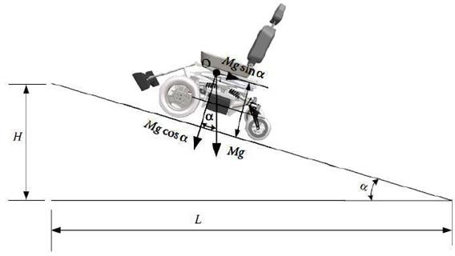

Fig 3.1 Forces in road inclinations.

The ascent resistance FB is calculated from the following formula:

*FB=Fz*Sinα ----------- (6)*

where Fz is vertical force in Newtons and α is the angle of the road inclination. As it is known, the tilt of the road is the ratio of the height H to the distance L (Figure 3.1) and expresses the height to be developed at a distance of 100 km:

*Ι = Η/L = tanα ≈ sinα ----------- (7)*

To find the angle α, in order to calculate the ascent resistance, the right formula is the following:

*Α=tan-1 (i) ----------- (8)*

Thus, for a pavement slope of 10O the vehicle has an ascent resistance equals to:

*FB= 1147.77 × Sin10 = 199.31 N -----------(9)*

Since the forces are opposing to the movement of the vehicle, it is accurate to be summed in order to find the required driving force (traction force) to be applied to the wheels in order to move it.

*Ftotal= Fr + FB = 17.2+ 199.31 = 216.51 N ----(10)*

where Ftotal is the total traction force which is the sum of ascent resistance FB and the rolling resistance Fr . The torque needed on the wheel to overcome these resistors is calculated by the formula:

*Ft = Mk * itot/rt => Mk = Ft*rt / itot ------- (11)*

where Mk is the torque on the wheel in Nm. The rt the radius of the wheel and itot its gear transmission ratio from the motor to the wheel. The motors have a diameter of 12inch (308mm) with a working voltage of 24V, 250Watt and a fixed gear transmission ratio of 23:1. The maximum torque that can be produced by the motor according to its operating diagram is 20Nm and is enough to overcome the climb and roll resistors.

*Ft = Mk* × *itot / rt*

*Mk = Ft* × *rt / itot*

*= 22* × *0.154 / 23*

*= 1.5 Nm*

**3.3 CALCULATION OF REQUIRED POWER**

Work results when a force acts upon an object to cause a displacement (or a motion) or, in some instances, to hinder a motion. Three variables are of importance in this definition - force, displacement, and the extent to which the force causes or hinders the displacement. Each of these three variables find their way into the equation for work. That equation is:

*W=F*χ ----------- (12)*

where W is the work in Joules, F is force in N and χ is the displacement in meters.

Considering the above mathematical formulas and knowing the velocity it follows that:

*P = Ft*Vt -----------(13)*

where P is the power in watts Ft is the traction force in N and Vt is the velocity in m/s. Theoretically, the power given to the vehicle, when it moves at the maximum speed (3.54m/s) it can develop (considering only the rolling resistance):

*P = 17.7N * 3.54 m/s = 62 Watt ------(14)*

The needed energy to drive the vehicle for one hour is calculated by the formula:

*E= P*t => E = 0.062KWh -------- (15)*

where E is the energy in KWh, P is power in watt and t is the time in hours According to the formula below, the vehicle needs 2.58Ah to move one hour at maximum speed.

*E = Qx*V/1000 => Qx=0.062*1000/24 => 0.062*1000/24 = 2.58Ah ------(16)*

Where E is the energy needed in Ah, Qx is the capacity of the battery in Ah and V is the voltage of the battery used in the experiment equal to 24V.

**CHAPTER 4**

**STATUS OF PROJECT WORK**

**4.1 COMPONENTS**

**4.1.1 Raspberry Pi 4**

Raspberry Pi 4 Model B is the latest product in the popular Raspberry Pi range of computers is shown in the fig 4.1. It offers ground-breaking increases in processor speed, multimedia performance, memory, and connectivity compared to the prior-generation Raspberry Pi 3 Model B+, while retaining backwards compatibility and similar power consumption. For the end user, Raspberry Pi 4 Model B provides desktop performance comparable to entry-level x86 PC systems. This include a high-performance 64-bit quad-core processor, dual-display support at resolutions up to 4K via a pair of micro-HDMI ports, hardware video decode at up to 4Kp60, up to 8GB of RAM, dual-band 2.4/5.0 GHz wireless LAN, Bluetooth 5.0, Gigabit Ethernet, USB 3.0, and PoE capability (via a separate PoE HAT add-on).

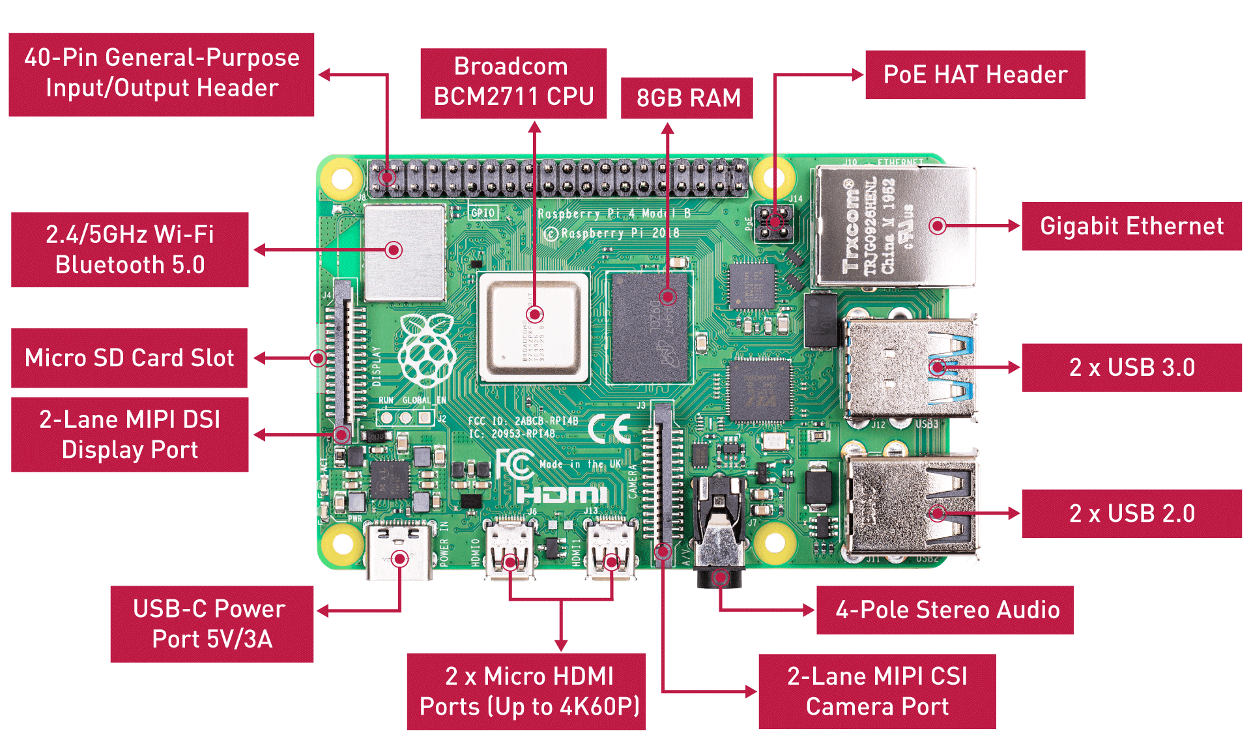

Fig 4.1 Raspberry Pi 4

**4.1.2 DC Motor**

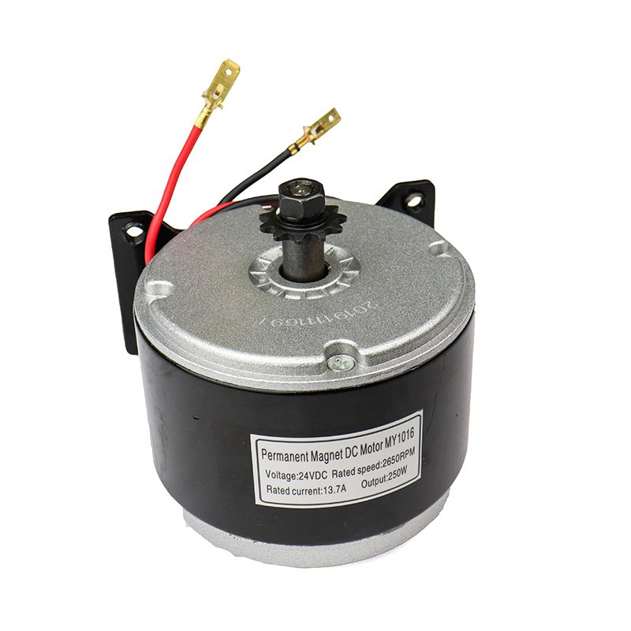

Fig 4.2 DC Motor

MY1016 250W 24V 2650RPM DC motor has 11-tooth, 4-bolt mounting bracket (threaded M6) on the base. As this is a DC motor it is capable of rotation in either the clockwise or counter clockwise direction by just reversing the battery polarity to the motor and can be speed controlled. It has an operating power of 250W, operating voltage 24V, rated current in the range of 9A to 11A and having a speed of 2650rpm. This motor is shown by fig 4.2 given below.

**4.1.3 Four Channel Relay**

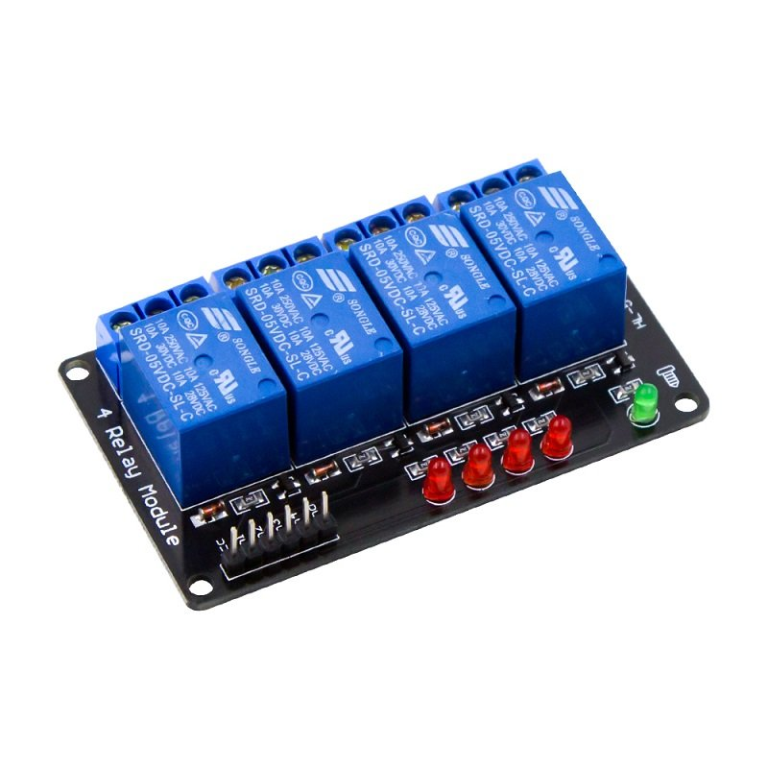

Fig 4.3 4-Channel Relay Circuit

The figure 4.3 shows 4-Channel Relay interface board and each one needs 15-20mA Driver Current. It can be controlled directly by Micro-controller with 5V input voltage.

**4.1.4 Lithium Ion Battery**

The figure 4.4 shows 12V 7.2Ah rechargeable lithium ion battery. Each battery weights 2.4kg.

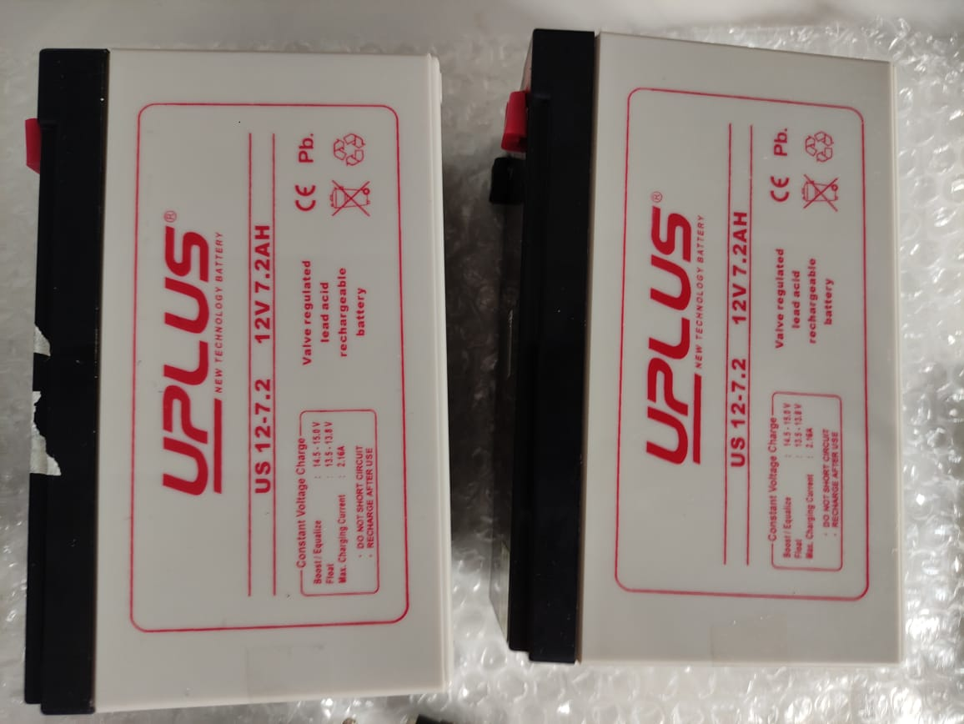

Fig 4.4 Batteries

**4.1.5 Adapter and Connector**

The figure 4.5 shows adapter with input 100 to 240V, 50 to 60Hz, 1.2A and gives an output 15V, 2.2A.

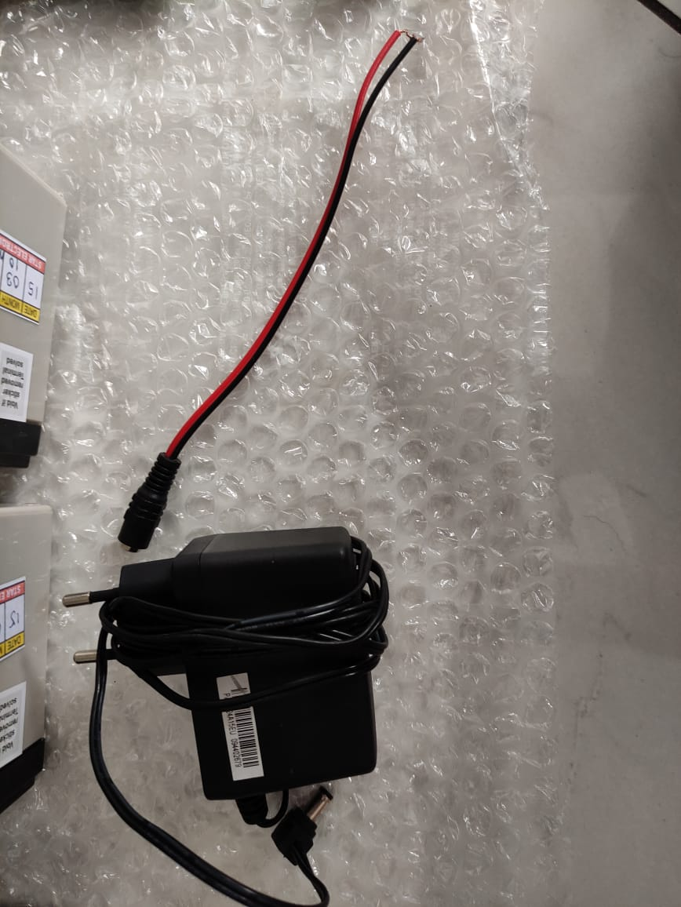

Fig 4.5 Adapter and Connector

**4.1.6 Node MCU**

ESP8266 Node MCU has powerful on-board processing and storage capabilities that allow it to be integrated with the sensors and other application-specific devices through its GPIOs with minimal development up-front and minimal loading during runtime. Its high degree of on-chip integration allows for minimal external circuitry, and the entire solution, including the front-end module, is designed to occupy minimal PCB area.

This WiFi development board already embeds in its board all the necessary components for the ESP8266 (ESP-12E) to program and upload code. It has a built-in USB to serial chip upload codes, 3.3V regulator, and logic level converter circuit so you can immediately upload codes and connect your circuits.

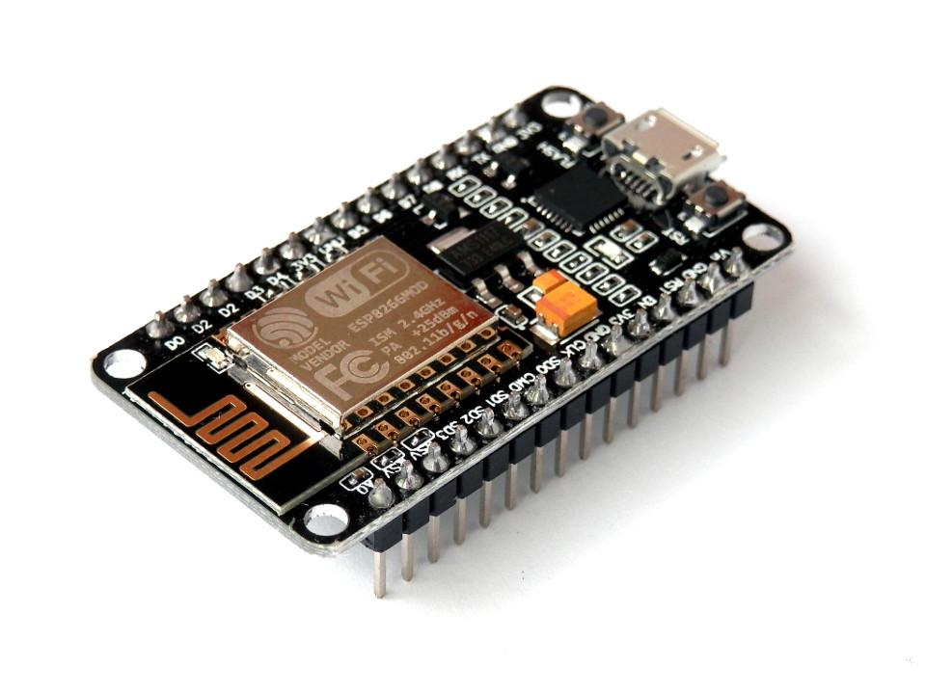

Fig 4.6 Node MCU

**4.1.7 Ultrasonic Sensor**

This HC-SR04-Ultrasonic is used for obstacle detection. The module has two eyes like projects in the front which forms the Ultrasonic transmitter and Receiver. It uses sonar to determine the distance to an object.

The Trigger and the Echo pins are the input pins of this module and hence they can be connected to the input pins of the microcontroller. When the receiver detects the return wave the Echo pin goes high for a particular amount of time which will be equal to the time taken for the wave to return back to the sensor. It provides 2cm-400cm non-contact distance sensing capabilities, ranging accuracy up to 3mm.

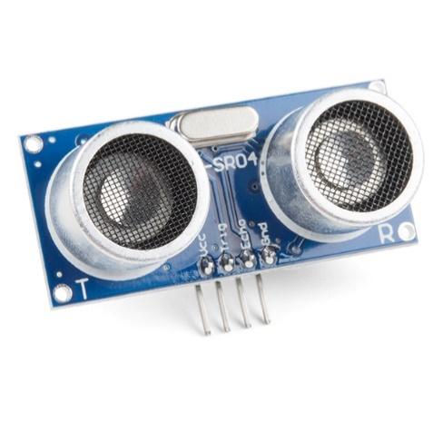

Fig 4.7 Ultrasonic Sensor

**4.1.8 Webcam**

The webcam is a video camera that feeds or streams an image or video in real time to the Raspberry Pi 4 in order to track the eye movements. The Webcam is connected to Raspberry Pi 4 using USB port.

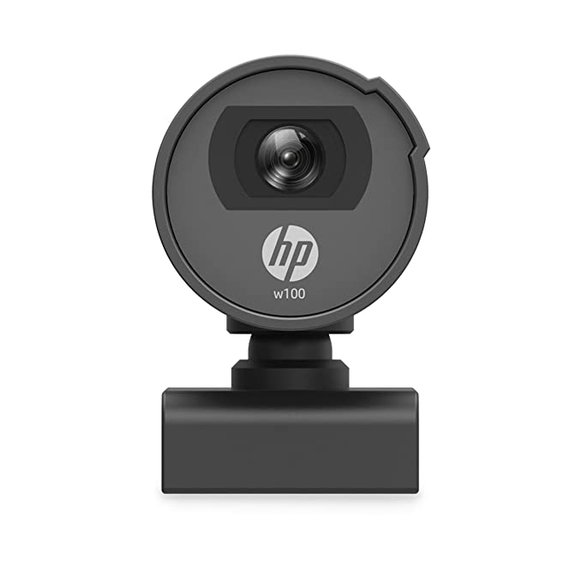

Fig 4.8 Webcam

**4.2 ESTIMATION**

Table 4.1 Estimation of components

|  |  |  |  |
| --- | --- | --- | --- |
| **SL**  **No.** | **Component Name** | **Quantity** | **Price** |
| 1 | 250W, 24V, 13.7A Motor | 2 | 4600 |
| 2 | 4 Channel Relay | 1 | 240 |
| 3 | 12V, 7.2Ah Battery | 2 | 1500 |
| 4 | 15V,2.2A Battery Charger | 1 | 250 |
| 5 | Node MCU | 1 | 500 |
| 6 | Ultrasonic Sensors | 4 | 400 |
| 7 | DC Wire Socket | 1 | 10 |
| 8 | Raspberry Pi 4 | 1 | 5100 |
| 9 | Webcam | 1 | 1500 |
| Total Cost | | | 14,100 |

**CHAPTER 5**

**EXPERIMENTAL SETUP**

**5.1 RASPBERRY PI CONFIGURATION**

* Materials required:
  1. Raspberry Pi 4
  2. RJ45 LAN cable
  3. 16GB SD card and adapter
* Software required:
  1. Raspbian OS
  2. VNC Viewer and VNC Server
  3. PuTTY Software

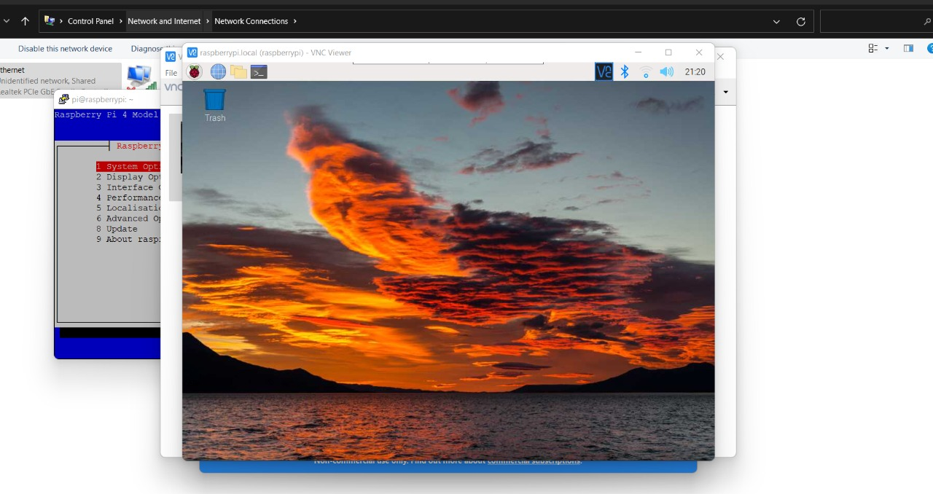5.1 Raspberry Pi 4 graphical interface setup

Raspbian OS is burned to a 16GB memory card and is connected to the Raspberry Pi 4. The microcontroller is then powered using USB type C connector and is connected with the computer using Ethernet cable (RJ45 LAN). The PuTTY software is started to connection with the microcontroller is established. VNC server is started and the same is enabled in microcontroller using PuTTY software. The VNC connect is executed and graphical interface is accessed as shown in 5.1. The necessary packages like OpenCV, Mediapipe, which are needed to run eye tracking program are installed using terminal.

**5.2 EYE TRACKING PROGRAM**

The components are connected as shown in the figure 5.2. The Raspberry Pi 4 is powered using a 5V, 2.5A power bank. A 4 Channel relay circuit is connected to GPIO pins (4,14,17,27) , Vcc and GND pins of Raspberry Pi 4. Two 250W, 24V DC geared motors are connected to the 4 Channel Relay circuit along with two 12V 7.2 Ah Lithium ion rechargable batteries.

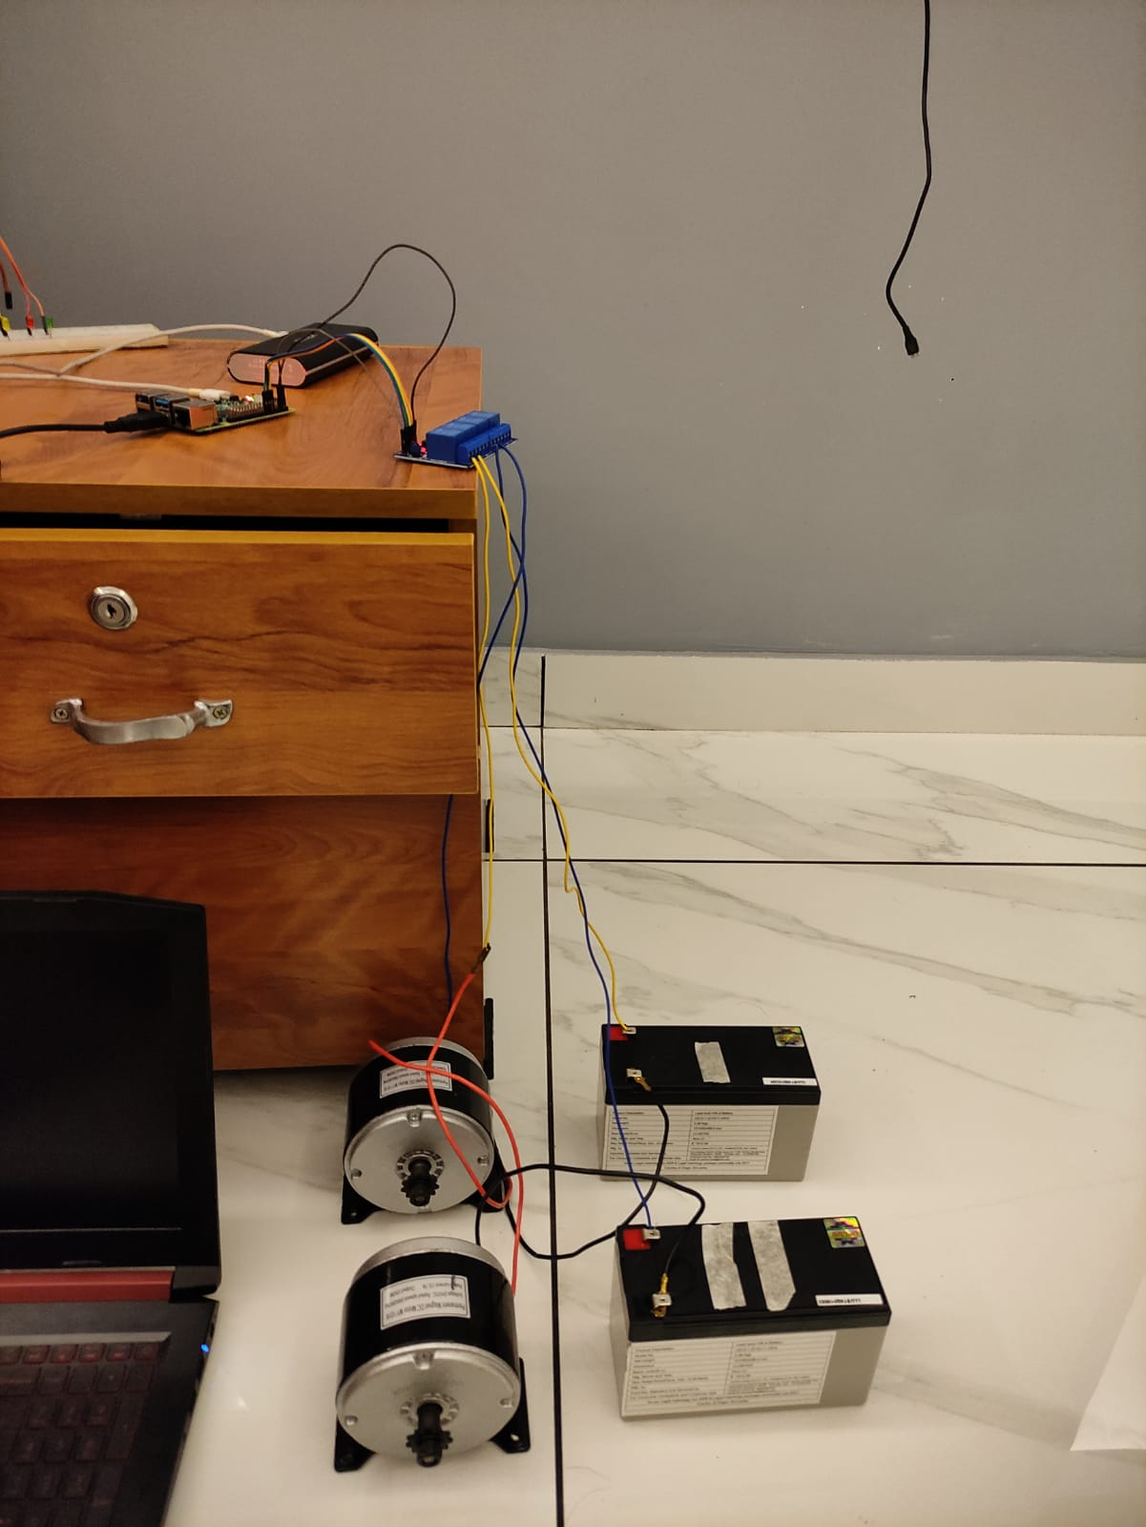 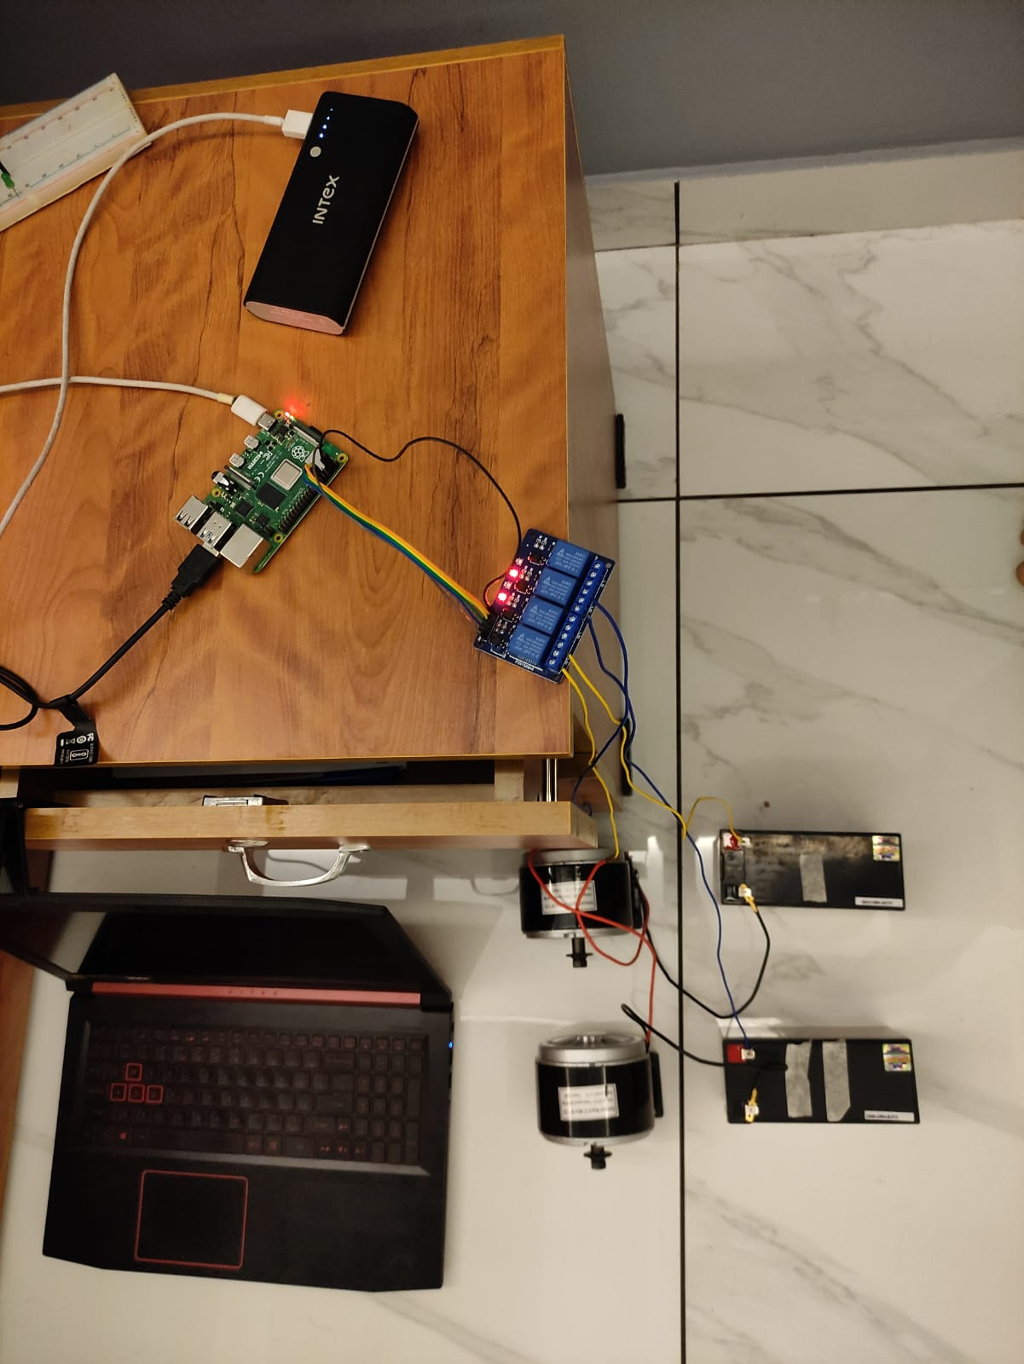

Fig 5.2 Experimental Setup

The program successfully executed on Raspberry Pi 4 and tracked various eye movements as shown in figure 5.3

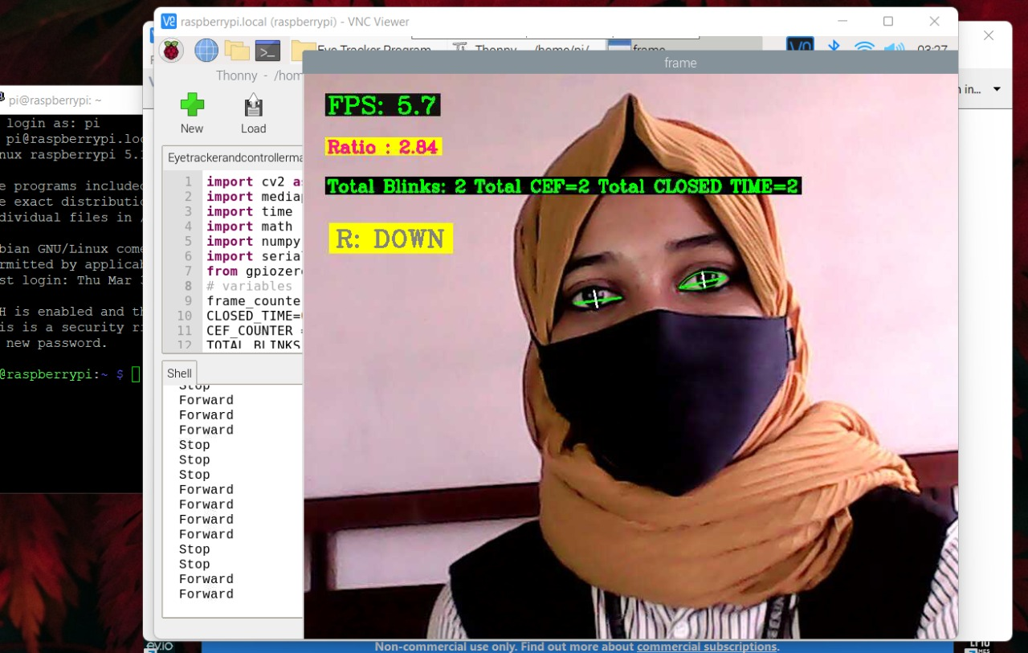

Fig 5.3 Result of Eye tracking program on Raspberry Pi 4.

The Raspberry Pi 4 is able to generate control signals for the relay circuits and that was verified using the LED lights in the same. But the relay circuit is not able to trigger the relays in order to rotate the motors. So as an alternative BTS7960B Bridge Motor Driver is selected for controlling of motors

**CHAPTER 6**

**CONCLUSION**

Paralyzed stroke patients are unable to normally communicate with their environment. The biggest problem that paralyzed patients face is leading their own lives without the assistance of others. As a solution to this problem, a smart wheel chair working with a home automation system that can be controlled by eye tracking is implemented in this work. The literature review for the proposed model are going on.

The eye tracking model is developed in python language using opencv and mediapipe libraries. Eye tracking technique, captures the image and detects the presence of human face. It detects the location of the eye on the face and conducts basic image processing operations such as color image to grey conversion, filtering, threshold, pattern matching, noise reduction, and circle detection on it after recognizing the face.

For the base controller, Raspberry Pi 4 has been selected. The Raspberry Pi board is utilized to control the entire operation of the system. It receives a signal based on digital image processing. The data was collected and analyzed using the Raspberry Pi. Based on the location of the eye pupil, the Raspberry Pi sends a control signal to the motor driving circuit. Two separate motors are placed in each wheel of a wheelchair. The wheelchair also has an ultrasonic sensor for detecting any stationary or moving obstacles. If the sensor detects an impediment that is quite close to the wheelchair, it will alert the Raspberry Pi, which will send a signal to the motor driving circuit to turn off the motor.

**REFERENCE**

1. **Ahmad F. Klaib, Nawaf . Alsrehin, Wasen Y. Melhem, Haneen . Bashtawi, Aws A. Magableh**. “Eye Tracking Algorithms, Techniques, Tools, and Applications with an Emphasis on Machine Learning and Internet of Things Technologies”, September 2020
2. **Pramodini A. Punde, Dr. Mukti E. Jadhav, Dr. Ramesh R. Manza**, “A study of Eye Tracking Technology and its applications”, *IEEE* 2017
3. **Tan Kian Hou, Yagasena and Chelladurai**“Arduino based voice controlled wheelchair”, 2020
4. **Mohammed Hayyan Al Sibai, Sulastri Abdhul Manap**, “A Study on Smart Wheelchair Systems”, *Research Gate* Dec 2015
5. **Deepak Kumar, Reetu Malhotra, S R Sharma**, “Design & Construction of a Smart Wheelchair”, *Science Direct* 2019
6. **Georges Boustany, Alaa El Deen Itani, Rayan Youssef, Omar Chami, Ziad O. Abu-Faraj**, “Design and Development of Rehabilitive Eye-Tracking Based Home Automation System”, *IEEE* 2016
7. **Joseph K George, Subin K B, Arun Jose, Hima T**, “Eye Controlled Home-Automation For Disables”, *IOSR-JEEE* 2017
8. **Deepak Kumar Lodhi, Prakshi Vats, Addala Varun, Prashant Solanki, Ritakshi Gupta1, Manoj Kumar Pandey, Rajat Butola**, “Smart Electronic Wheelchair Using Arduino and Bluetooth Module”, *IJCSMC* May 2016
9. **Airi Ishizuka, Ayanori Yorozu and Masaki Takahashi**, “Driving Control of a Powered Wheelchair Considering Uncertainty of Gaze Input in an Unknown Environment”, *MDPI*, 2018
10. **Mohammed Hayyan Al Sibai and Sulastri Abdul Manap**, “A Study on Smart Wheelchair Systems”, *International Journal of Engineering Technology and Sciences*, 2015
11. **Mohammad A.Eid, Nikolas Giakoumidis and Abdulmotaleb EL Saddik**, “A Novel Eye-Gaze-Controlled Wheelchair System for Navigating Unknown Environments: Case Study with a Person with ALS”, *IEEE Access*, 2016
12. **Yi-Chen Lee, Ching-Min Lee**, “Real-Time Smart Home Surveillance System of Based on Raspberry Pi”, *IEEE Access*, 2020
13. **Muhammad Azlan Alim, Samsul Setumin, Anis Diyana Rosli, Adi Izhar Che Ani**, “Development of a Voice-controlled Intelligent Wheelchair System using Raspberry Pi”, *IEEE Access*, 2021
14. **V.Usha Rani, Dr.J Sridevi, P. Mohan Sai**, “Web Controlled Raspberry Pi Robot Surveillance”, *IEEE Conference*, 2021